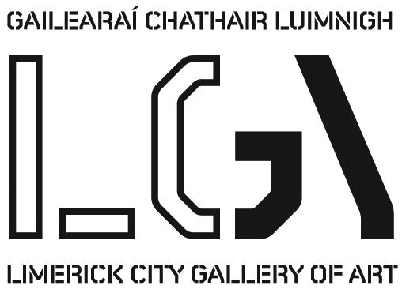
SELVA OSCURA

Nel mezzo del cammin di nostra vita
mi ritrovai per una selva oscura
che la diritta via era smarrita

Trans. Halfway on our life’s journey, in a wood,
From the right path I found myself astray.
(Heaney, 1993)
Dante Alighieri, The Divine Comedy – Pt. 1 Inferno – Canto 1 – (1-3)

***

In a 1935 letter from T. S. Eliot to the poet Stephen Spender writing of critical or rather aesthetic responses to works of art, Eliot insisted "Even just the bewildering minute counts; you have to give yourself up, and then recover yourself, and the third moment is having something to say, before you have wholly forgotten both surrender and recovery. Of course the self recovered is never the same as the self before it was given." This sentence with its implication of both an association between aesthetic and sexual surrender and the utterly transformative effects of the experience of the work of art is significant for me. Eliot’s term “the bewildering minute” uses an old English word which first appeared in usage in the 1680s ‘bewilder.’ Probably derived from the word wilderness, be-wilder originally meant ‘to lure into the wilds’ and therefore ‘ to lead astray’ from which arises its current meanings ‘to cause to lose one’s bearings’ and ‘to perplex or confuse.’

***

Working on the floor of my studio over the last several months in a lying position, my face just centimetres from the paper’s surface in the purgatorial task of making these very large drawings, I have constantly lost my bearings, the boundaries of the paper’s edges far beyond the limits of my peripheral vision. Bewildered, led astray in repetitive tasks, immersed in the transformative acts of making, losing ones’ bearings in the making of works such as this group of large drawings becomes normal. To choose to accept being lost in the work’s making is better.

***

In Franz Schubert’s Die Winterreise (The Winters Journey) a lone traveller trudges steadily through the cold landscape of winter in the cycle of twenty-four songs based on poems by Wilhelm Müller. Rejected by the woman he loves, despairing in his flight from the town where she lived, his growing hopelessness for and with the culture and society that has rejected him, the journeyman grimly resolves to forge ahead towards the death that will finally end his journey. Described by Schubert himself as "a cycle of horrifying songs" the group of songs posit a world in which the protagonist is simultaneously within and without the world he inhabits. Romance simultaneously does and does not exist (not to mention God); the music is entirely Franz Schubert’s, and yet simultaneously, not exactly. Schubert is identified with the song of his hero (obviously simultaneously his anti-hero) while simultaneously being remote from it. Die Winterreise is both a world of Franz Schubert’s own imaginative construction and simultaneously an artwork from which he must remain apart. Published in 1828, Die Winterreise was the last work which Schubert completed before his death from medicinal mercury poisoning.

***
Presenting an image that could only exist at the edge of a forest wilderness, looking down upon a demarcated agricultural landscape receding into a distance, these drawings evoke the experience of being at the end of that kind of place. The wilderness exists here behind the viewer’s position, in the viewer’s imagination and in their memory; the ultimate aim being to cause the viewer to think about what they cannot see because of what they now can. This is a liminal zone, between territories, and the viewer is at the edge of one kind of experience, looking down towards another, on a cusp, a Bardo, between one dark place and one bright.
Michael Canning
October 2014

Michael Canning

Lights Leaving X, 2008
Oil and Wax on canvas mounted on board
50 x 35 cm
Private Collection

Selva Oscura I , 2014
Acrylic, Watercolour, Soot, Charcoal, Ash, Pencil on Paper
305cm x 213cm,
Courtesy Dolan/Maxwell, Philadelphia

Selva Oscura II 2014
Acrylic, Watercolour, Soot, Charcoal, Ash, Pencil on Paper
305cm x 213cm
Courtesy Oliver Sears Gallery, Dublin

Selva Oscura III 2014
Acrylic, Watercolour, Soot, Charcoal, Ash, Pencil on Paper
300cm x 427cm,
Courtesy Dolan/Maxwell, Philadelphia

Selva Oscura IV 2014
Acrylic, Watercolour, Soot, Charcoal, Ash, Pencil on Paper
305cm x 213cm
Courtesy Waterhouse & Dodd, London.

Michael Canning was born in Limerick in 1971. After studying at the Limerick School of Art and Design he studied in Greece at the School of Fine Arts in Athens 1992-1993 and in 1999, he received his Masters Degree in Fine Art from the National College of Art & Design in Dublin. Michael Canning’s paintings confront certain traditions of northern European painting. Neither landscapes, nor still-lifes, they convey an atmospheric quality laden with spiritual undertones. Michael has exhibited extensively throughout Ireland and The UK. His work is included in several private and public collections including: AIB, McCann Erickson, AXA, Butler Gallery, University of Limerick, OPW Ireland. He won the Hennessy Craig Scholarship in 2003 & the Fergus O'Ryan Memorial Award in 2006, both at the RHA, Dublin
http://michaelcanning.tumblr.com/
https://twitter.com/CanningMichael
http://instagram.com/michael_canning_#

Exhibition runs 28th November 2014 to 8th January 2015

For further information please contact artgallery@limerick.ie Tel: 061 310633

Opening Hours: Monday- Friday 10-5.30, Thursday 10-8.30; Saturday 10-5pm & Sunday 12-5pm
Closed on Bank Holidays



